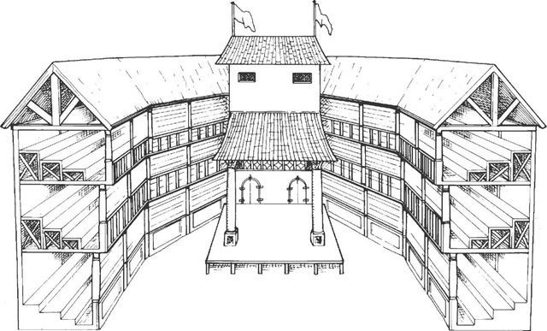

**Attitudes Towards the Theatre**

Support- Popular form of cheap entertainment, attracting large audiences. Plays were produced with gripping storylines and iconic characters. Plays delivered patriotic messages in support of the queen. Against- The authorities saw it as a threat to law and order, saying it encouraged beggars and pickpockets. Puritans and other religious groups saw it as the work of the devil, saying the plays lacked decency.

**Playwrights**

**Elizabeth’s reign witnessed the ‘Golden Age’ for playwrights-**

* William Shakespeare – Wrote at least 37 plays, comedies, tragedies and historical dramas. Most productive and popular playwright.
* Christopher Marlowe – played a leading role in developing the tragedy, most famous work – Doctor Faustus, stabbed to death in tavern brawl.
* Thomas Kyd – important in developing the drama, a close friend of Marlowe.
* Thomas Dekker – wrote mainly comedies

**The Actors**

All parts were played by men, each actor with a number of roles:

Richard Burbage-a tragic actor that went on to co-own the globe

Thomas Pope – a comic actor and acrobat

Theatres opened in Shoredage, London like:

1. The Theatre (1576) 2. The Rose (1587) 3. The Globe (1599)

Design of the Theatre

**Formation of Theatre Companies**

In 1572, a law was passed to ban strolling players without a license. This led to formation of TCs –

1. Lord Chamberlain’s Men (formed in 1594)

2. Earl of Leicester’s Players (formed in 1574)

**Band of Strolling Players**

Actors toured the countryside, performing in towns or villages. Popular for lower classes

**The Development of Elizabethan Theatre**

**The Importance of Popular Entertainment**

For some, Sunday was the only rest day, the day of worship. Cruel Sports – Enjoyed by all sections of society **Bear and bull-baiting** – bears chained to stake and attacked by dogs. The “Bear Garden” took 1000 people in London. **Cockfighting** – took place in pits with people betting on which cock would win.

**The rich had much more leisure time, enjoying hobbies like… Hunting-**in their own deer parks **Hawking-** use of a trained hawk for hunting. **Archery**- popular in the Tudor period **Dancing, music and singing-** employed to entertain them. Ball **Games** – tennis, bowls and skittles. Football popular in lower class but the wealthy often played on horseback.

Popular Entertainment