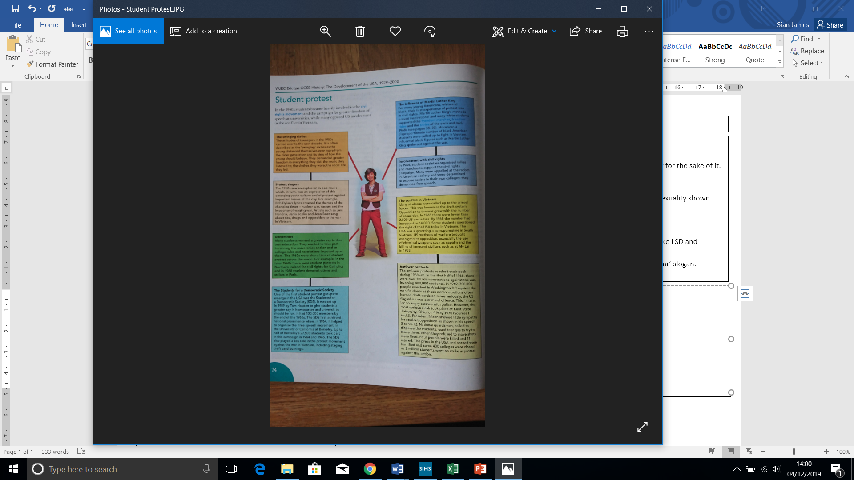

**Changing role of women**

Women saw increased employment, status, pay, equality and a change to their traditional ‘family role’

*Impact of WWII*

*1950s*

*Feminist movement 1960s-1970s*

*Growth in feminism 1980s-2000*

However, by 1998 the earnings of women were still only 75% of those of men.

**Student protest and its impact**

During the 1960s onwards students became heavily involved in protest movements such as the Kent State protests in May 1970

*Influence of the Swinging Sixties*

*The SDS (Students for Democratic Society)*

*Anti-war Protests*

*Influence of Protest Singers*

*Campaign for civil rights*

**Youth Culture**

**Teenage rebellion 1950s**

More money, freedom and free time than ever before. Many wanted to rebel against parents or for the sake of it.

Distinctive clothing, gangs, cruised in cars, drank alcohol, attacked property.

*Beatniks* – dropped out of conventional society.

Elvis Presley and Little Richard became heroes to a new youth culture, parents disliked upfront sexuality shown.

**Hippy movement 1960s**

* 1960s, young people rejected ideas of their parents.
* Dropped out of society and became hippies – ethic style clothing, long hair, took drugs like LSD and marijuana, mystical religions and engaged in ‘free love’.
* Opposed Vietnam War, wore flowers in their hair as a symbol of peace ‘Make love not war’ slogan.
* Settled in communes and San Francisco became hippy capital of the USA.

**IT**

1975 Bill Gates set up Microsoft

1976 Apple Computer Inc set up by Steve Jobs

1980s rise of computer games

1985 Microsoft Windows launched

1990s growth of internet

2000s Xbox, email, social media, text-based discussion.

**Literature**

*Great American Novel -* To Kill a Mockingbird etc.

*Counterculture –* Feminine Mystique etc.

**Cinema**

Cinema popular after WWII, then lost appeal due to TV ownership, then flourished with blockbusters like Jaws.

Drive-ins, Multiplexes, VCR ownership.

*Anti-hero* – James Dean, Marilyn Monroe

*Method Actors* – Tom Cruise, Meg Ryan, Jack Nicholson.

*Special effects* – The Terminator

**Music**

**1950s –** rock and roll, Elvis, music of their own.

**1960s –** Beatles & other British groups influenced USA, Protest songs, Bob Dylan, Rock music more influential.

**1970s/80s –** Disco went with drug movement, popular amongst women, Donna Summer, Beejees. Metal bands popular amongst males. Solo artists such as Bruce Springsteen popular amongst working class. Rap and hip-hop product of inner-city issues.

***Cinema, music, literature, information technology all influenced social change – particularly for the young and women.***

Social Change 1950-2000