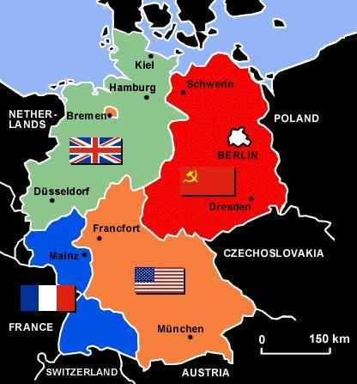

Cold War Rivalry

**Berlin Crisis 1948-49**

*Main flashpoints of the Cold War in Europe concerned attempts by the West to stop the threatened spread of communism.*

Germany split into 4 zones, Berlin split as well.

1948-USA, British & French zone merged, had new currency and became more prosperous.

Stalin worried Western Berlin capitalist base in communist Eastern Europe.

1948 Berlin Blockade by Stalin, Truman determined to contain communism, flies in aid to West Berlin until May 1949 when Stalin gave in. Truman saw it as a victory.

**USA joins NATO, 1949**

North Atlantic Treaty Organisation set up in April 1949.

By 1955 the USSR had set up the Warsaw Pact in retaliation.

**Vietnam**

**US involvement**

Vietnam was a French colony, then divided between North (communist) and South (non-communist). 1963 leader of South overthrown, US feared communists would take over the south, US needed to act to continue containment and avoid Domino Theory coming true. Gulf of Tonkin, Aug 1964 US destroyer fired on by North Vietnamese, Johnson sent in troops to aid South Vietnam.

**Methods of Warfare**

Operation Rolling Thunder 1965-8 aim of destroying Vietcong supply routes to the south.

Chemical warfare – Agent Orange used to destroy the jungle, napalm also used.

High-tech war, USA had latest technology, B52 bombers, helicopters, rocket launchers.

Increasing troop numbers – 180,000 in 1964 rising to 540,000 in 1968.

‘Search and destroy’ US troops would search villages for Vietcong then set alight to them – made them unpopular.

**Reasons for defeat**

Inexperienced troops, Growing opposition at home, The Tet Offensive (1968), Vietcong Tactics, Support of Communism, USSR and Chinese support.

**Consequences of US withdrawal**

Nixon’s policy of Vietnamisation (transferring fighting from US troops to Southern Vietnamese troops), started peace talks in 1969.

1973 ceasefire signed, peace treaty followed then all US troops left Vietnam.

North Vietnam kept captured land, 1975 communist forces gained more land in the South, by 1976 country united under Ho Chi Minh.

Domino Theory came partially true – Laos and Cambodia soon turned communist.

**Truman Doctrine and containment of Communism**

*The USA and USSR had worked together during WWII to defeat Germany, after the war relations deteriorated.*

Ideology: 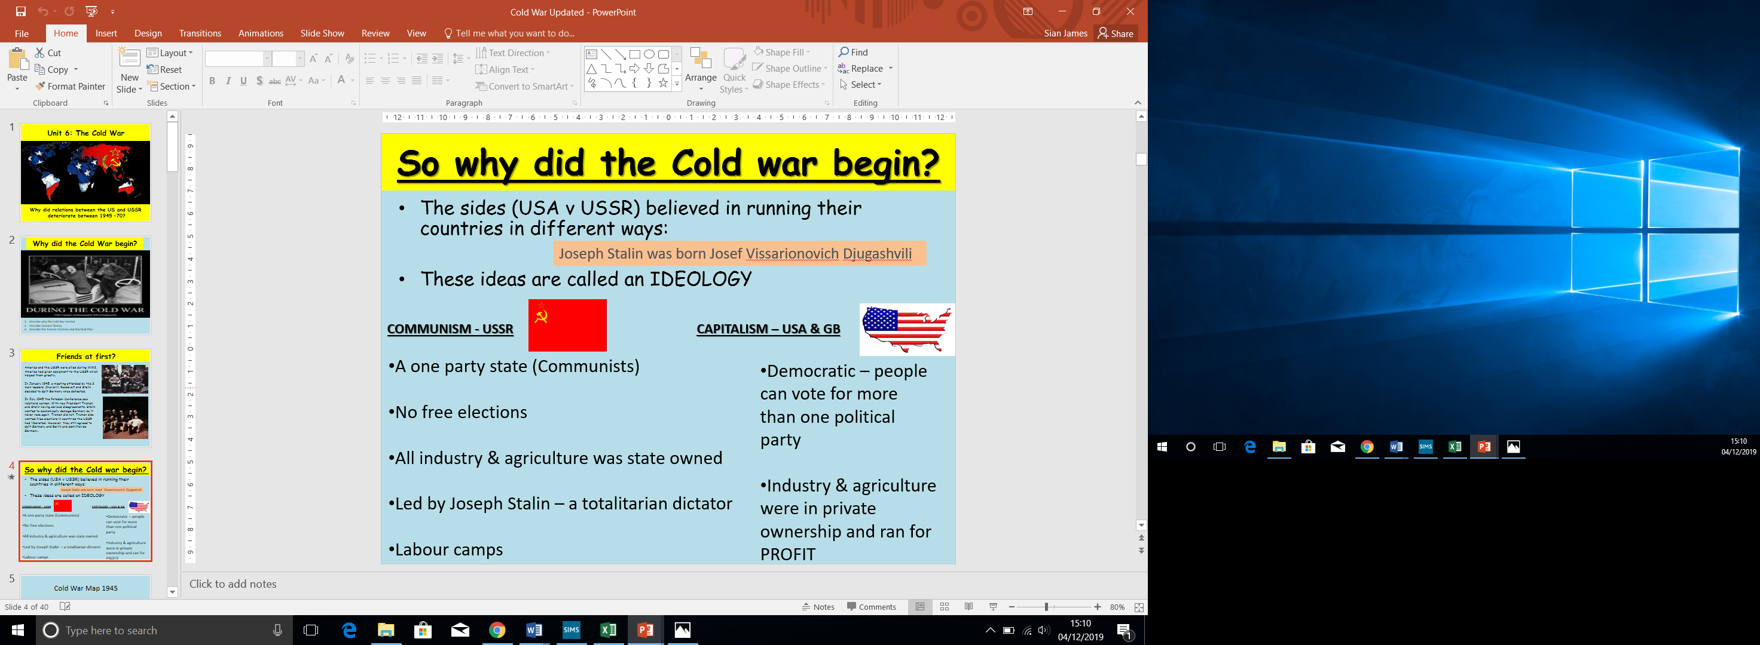

**Marshall Plan 1947**

Truman gave economic aid to Europe as part of his containment plan. Marshall, Secretary of State, offered over $13 billion to aid countries recovering from WWII. The USA believed that countries with a strong economy could repel communism. Stalin refused to let Soviet Satellite states to accept Marshall Aid, but 1953 the USA had provided $17billion of Marshall Aid.

**Domino Theory**

Containment was based on ‘Domino Theory’, if one country fell others neighbouring would fall. America’s policy was to stop the most unstable domino from falling.

**Iron Curtain**

Invisible barrier between East/Western Europe.

**Cuban Missile Crisis**

**Causes**

Jan 1959 Batista overthrown by left-wing Castro in Cuba. Castro ejects all US businessmen, USA refuse to buy sugar, USSR buys it instead. Castro worried USA so Kennedy supported landing of Cuban exiles at the Bay of Pigs in Cuba – ended in disaster & embarrassment. Khrushchev concerned about US missiles in Italy & Turkey so wanted Soviet bases in Cuba – Castro agreed.

**Key Events**

14 Oct U2 spy planes photographed Soviet missile sites being built in Cuba

20 Oct Kennedy imposed naval blockade around Cuba.

23-27 Oct US and USSR leaders sent messages to each other to remove blockades, withdraw missiles from Cuba and Turkey.

28 Oct USSR agreed to remove missiles from Cuba.

**Consequences**

USA won, brinkmanship, hotline, 1963 Test Ban Treaty.