Year 7 drawing tasks
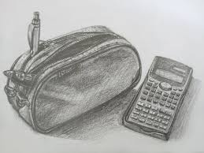Draw the contents of your pencil case and shade
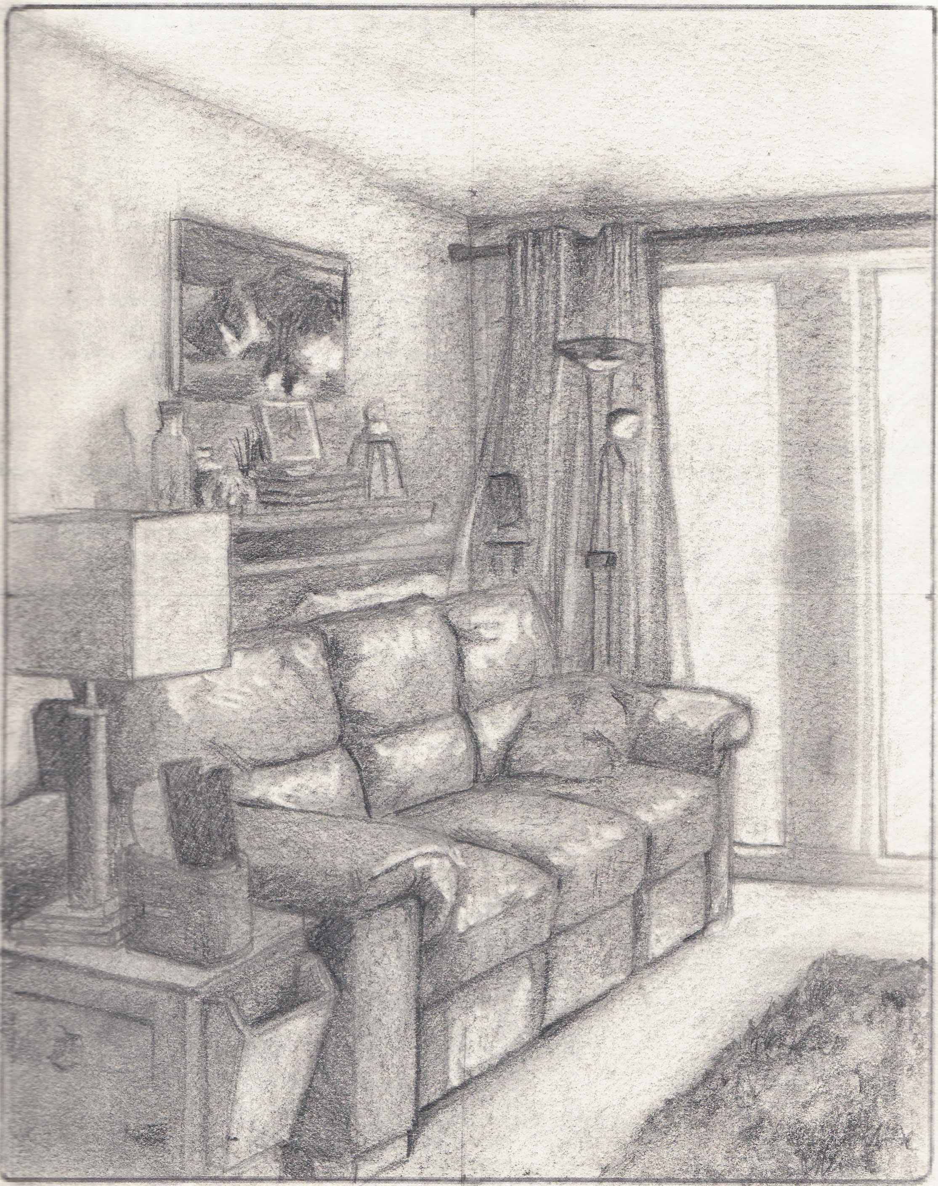Draw a corner of a room in your house and shade
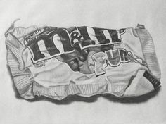Draw a scrunched piece of packaging and shade it

