Year 8 drawing tasks
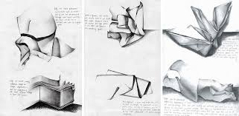
Draw and shade six different creased pieces of paper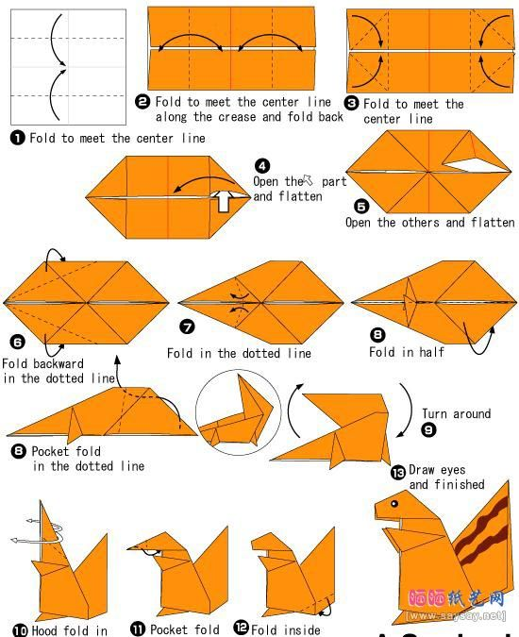
Produce a step by step origami guide and make them
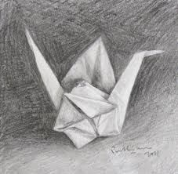
Draw and shade the origami piece from your guide

