Year 9 drawing tasks
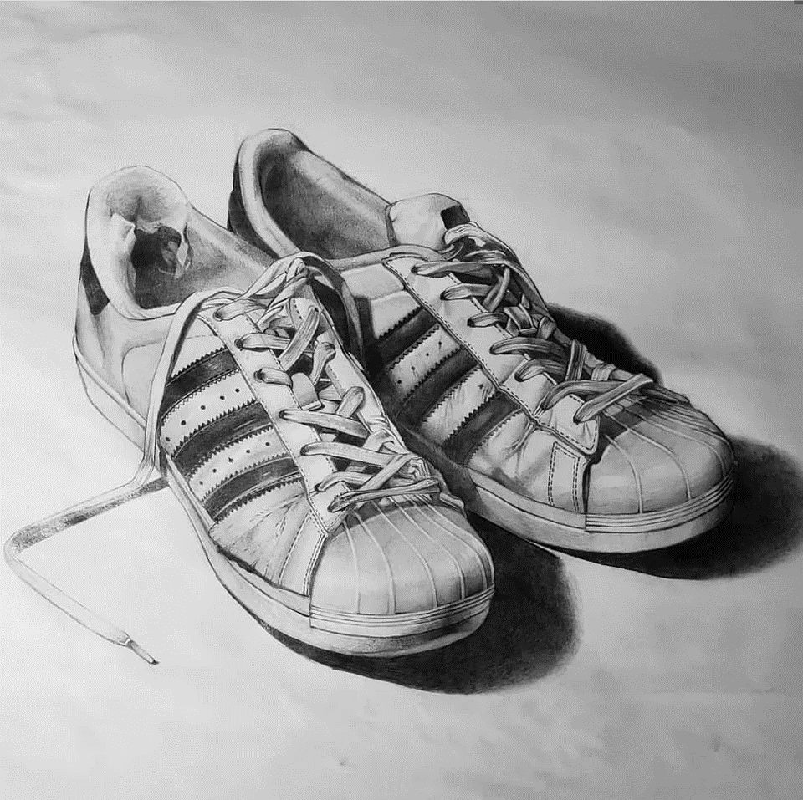 Draw a pair of trainers and shade
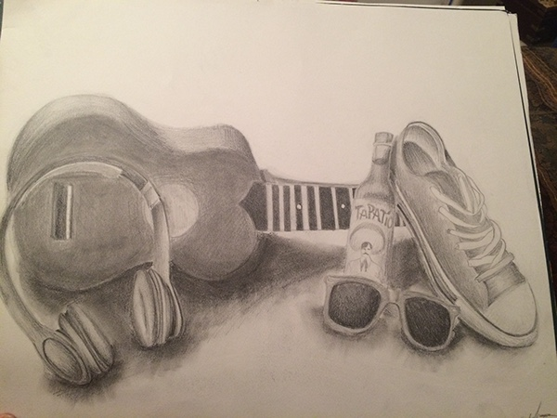
Draw and shade a selection of five man- made objects
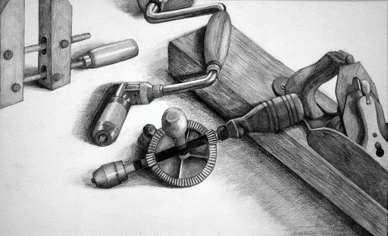
Draw and shade a selection of tools together

